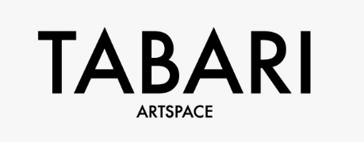
Mohamed Abla: The Silk Road
10 October – 24 November 2017

First exhibition marking relaunch of Dubai gallery Tabari Artspace
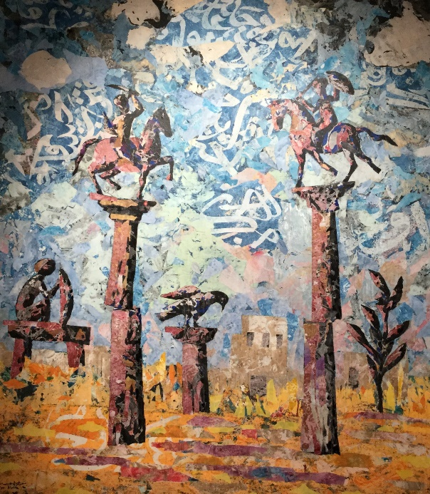
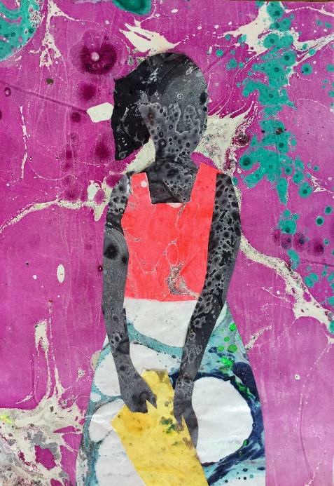

Left: Mohamed Abla, The Princess, 2016-2017, mixed media, courtesy the artist
Right: Mohamed Abla, The Copper City, 2016-2017, mixed media, courtesy the artist

Tabari Artspace is pleased to announce the new name and visual identity of their gallery formerly known as ARTSPACE Dubai. A solo exhibition of new works by one of Egypt’s most influential and established contemporary artists, Mohamed Abla will be the first at the gallery under its new name.

Mohamed Abla: The Silk Road includes a selection of abstract artworks which synthesise calligraphy, collage and traditional Middle Eastern techniques which explore folktales from North Africa, the Levant, Central Asia and the Indian subcontinent.

A common theme in Abla’s work is the exploration of new methods of mark making. For The Silk Road series, the artist employs the Turkish Ebru technique (paper marbling), which is the act of floating paper in a tray filled with water and oil paint. The paint is then carefully transferred to the surface of the paper to create colourful marble-like patterns. Abla cuts shapes from the variously dyed papers, arranging them into compositions resembling animals, heroes, princesses and other folktale figures and imagined scenes derived from the ancient Silk Road network, which was operational from around 120 BCE to 1450s CE.
Narratives play an important role in Abla’s work, and the inspiration for this series stems from the artist‘s research into the history of the Silk Road, as well as recent travels to India, Syria and Iraq. In his works, the artist selects specific folktales which he sees as symbolic of the unsettling political and economic issues in Egypt following the Revolution in 2011. Abla reimagines the activity of the Silk Road through his artwork and draws parallels between past and present politics of the East and West. In another work, The Copper City, Abla chose a Pakistani fairy tale as a point of departure. In the story, all of the inhabitants of a city have been turned into copper except for the princess who is locked in a tower. In a conclusion similar to that of the German fairy tale Rapunzel, a hero rides through the frozen city and saves her. This fable symbolises political and social unrest in many of the countries within the Silk Road network, which paralyse government efforts to address wider problems within their countries.

About Tabari Artspace
Tabari Artspace, formerly Artspace Dubai, has been a pioneer in establishing a contemporary art scene in Dubai since it was founded in 2003 by collector and art consultant, Maliha Tabari. A strong passion for the arts led Maliha to become an expert in contemporary art in the Middle East, building her own personal collection and advising on the establishment of others.

The gallery represents and champions a range of established artists and is dedicated to the global promotion of modern and contemporary Middle Eastern art. As an internationally-facing commercial art gallery, Tabari Artspace continues to support artists from the region, working across a varied range of media, including: Mohamed Abla, Lulwah Al-Homoud, Adel El Siwi, Hussein Madi, Zakaria Ramhani and Khaled Zaki as well as working in close collaboration with the family and estate of The Alfred Basbous Foundation.

Tabari Artspace offers both local and international audiences the opportunity to discover artists from this region through participation in international art fairs, and facilitating relationships with significant private collections and museums, including LACMA, the Guggenheim Abu Dhabi and Barjeel Art Foundation.

About Mohamed Abla
b. 1953 Mansoura, Egypt, Mohamed Abla lives and works between Cairo and Fayoum, Egypt and Walsrode, Germany.

After graduating from the Faculty of Fine Arts in Alexandria (1973), Abla embarked upon a seven-year journey around Europe, where he visited museums in Spain, France, Belgium and Germany, eventually studying art, sculpture and graphics in Vienna and Zurich.
His first solo exhibition ran at the Hohmann Gallery, Hamburg, Germany (1979), followed by shows at Gallery Ewat, Leeuwarden, The Netherlands (1989); Art Hall, Örebro, Sweden (1991); and the Egyptian Academy of Rome, Italy (1991), amongst others. Later, he moved back to Egypt where he held several solo exhibitions around the country. In 1994 he won the First Prize at the Kuwait Biennial, followed by the Grand Prix at the Alexandria Biennale, Egypt, in 1997. He has also participated in several international art events such as the Havana Biennial, Cuba and his work has been part of several group exhibitions at the Kunstmuseum in Bonn, Germany.
Abla has also founded several artistic institutions which connect artists locally, regionally and internationally through artistic creation. In 2007, Abla founded the Fayoum Art Center, Egypt, where artists meet, work and collaborate. In 2009, he established the first caricature museum in the Middle East, also in Fayoum.

Press contact:
Carlotta Dennis-Lovaglio or Saskia Deliss at Pelham Communications
+44 (0)20 89693959
carlotta@pelhamcommunications.com or saskia@pelhamcommunications.com

Exhibition Facts

Title: | Mohammed Abla: The Silk Road
Address: | Tabari Artspace, The Gate Village Building, Level 2, DIFC Dubai, UAE 506759
Telephone: | + 971 4 323 0820
Website: | www.tabariartspace.com
Dates: | 10 October – 24 November 2017
Private View: | Tuesday 10 October, 7 - 10pm
Opening Hours: | Sunday – Thursday, 9am – 9pm

