TAGREED DARGHOUTH
STRANGE FRUIT

March 18th – May 1st

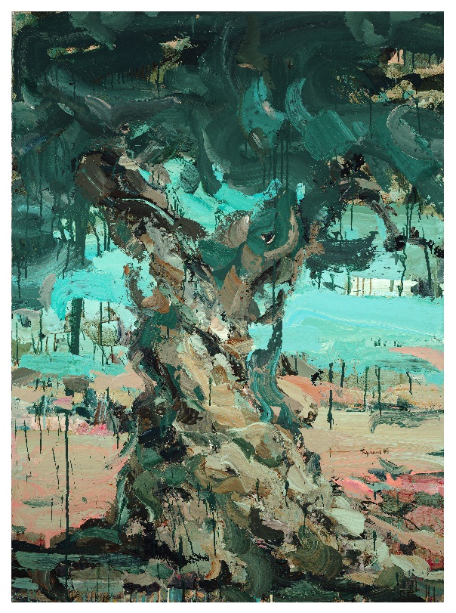

Tabari Artspace is delighted to announce Strange Fruit a solo exhibition of works by acclaimed female, Lebanese painter, Tagreed Darghouth.

Concerned with the socio-political issues prevalent in her native Lebanon and beyond, Darghouth takes a research-driven approach to her works, primarily in acrylic on canvas, that tackle such topics as cosmetic surgery, domestic workers, life and death, war, destruction, identity, and displacement. The artist draws inspiration from literature, philosophy, and the everyday realities of the Middle East as well as European Masters like Rembrandt van Rijn and Vincent van Gogh to produce paintings that are not only uncomfortable, confronting, and challenging in their subject matter but also technically brilliant.

Strange Fruit will be the first ever solo exhibition of works by Darghouth in Dubai. The series on display sees a juxtaposition between pastoral landscapes populated with Palestine’s ubiquitous olive trees and images depicting the destruction and violence resulting from the occupation. Allegedly, approximately 800,000 olive trees in occupied Palestine have been uprooted since 1967. Darghouth’s paintings, that refer to this destruction of the Palestinian olive groves, are imbued with the sentiments of Van Gogh on the significance of the olive tree as a ‘symbol for human life and its cycle’. Van Gogh believed that human interaction with nature, particularly during the olive harvesting season, formed a connection to the Divine. Darghouth also takes inspiration from these closing words by poet Mahmoud Darwish in The Second Olive Tree:

But one of her grandsons
Who witnessed the execution threw a stone
At a soldier, and was martyred with her.
After the victorious soldiers
Had gone on their way, we buried him there in that deep
Pit-the grandmother cradle. And that’s why we were
Sure, that he would become, in a little while an olive.

“This exhibition is another attempt to throw a stone.” -Tagreed Darghouth

On the power of art as social commentary Tagreed Darghouth says:
“I think painting’s visual nature makes it an extremely powerful medium and mode of communication. A painting can cause much impact – all it requires is a mere glance from the observer.
In my opinion it’s an artist’s duty to use this mighty language to shed light on matters that concern him or her and their surroundings.

On the exhibition Tabari Artspace founder Maliha Tabari Says:
“It seemed more than fitting that we dedicate March, which is the busiest month in Dubai’s art calendar and also Women’s Month to a powerful female force in the Middle Eastern art scene such as Tagreed Darghouth.

Aside from her talent as a painter which is obvious, Darghouth deals with subject matter that many artists shy away from, yet her work provides an important insight into the social issues of the now.”

-ENDS-
ABOUT TABARI ARTSPACE
Founded in 2003 by Maliha Tabari, Tabari Artspace is a gallery based in DIFC, Dubai specialising in modern and contemporary Middle Eastern art.
As an internationally-facing, commercial art gallery, Tabari Artspace plays a pivotal role in the advancement and growth of the Middle Eastern art scene supporting artists from Palestine, Egypt, Lebanon, Saudi Arabia, and beyond.
Tabari Artspace offers both local and international audiences the opportunity to discover artists from this region through participation in international art fairs, and facilitating relationships with significant private collections and museums, including LACMA, the Guggenheim Abu Dhabi and Barjeel Art Foundation.

ABOUT TAGREED DARGHOUTH
Born in Saida, Lebanon in 1979, Tagreed Darghouth obtained a degree in Fine Arts at the Lebanese University in Beirut, as
well as a diploma in art education. She participated in the Ayloul Summer Academy, led by the Syrian-German artist Marwan Kassab Bashi, at Darat Al Funoun in Amman in 2000 and 2001. She then went on to study Space Art at the Ecole Nationale Supérieure des Arts Décoratifs in Paris.

Tagreed’s social and political themes draw attention to forms of structural violence and misconceptions of the Other. In 2004, Darghouth had her first solo exhibition, Still Features, at Zico House in Beirut, which was then followed by Falling Parts at the Goethe institute in Beirut in 2006. She has since had several solo exhibitions in Agial Art Gallery, including, Mirror, Mirror! in 2008, Fair & Lovely in 2010, Canticle of Death in 2011, Rehearsals in 2013, and Vision Machines, Shall You See Me Better Now? In 2015. Most recently, in 2018, Saleh Barakat Gallery held Darghouth’s exhibition Analogy to Human Life.

She has participated in numerous group exhibitions around the world, in Al-Sharjah, Amman, Beirut, Brussels, Buenos Aires, Doha, Dubai, Jordan, Istanbul, London, Miami, Berlin, New York, Paris, and Singapore, among other cities, which includes the 10th Anniversary of the Kasa Art Gallery exhibition in Istanbul in 2010, Connecting Heavens at Green Art Gallery in Dubai in 2010, Subtitled: With Narratives from Lebanon at the Royal College of Art in London in 2011, and Thin Skin: Six Artists from Beirut at Taymour Grahne Gallery in New York in 2014. Darghouth has received several prizes, including the 2nd Prize at the Ayloul Summer Academy exhibition in Darat al Funoun in Amman in 2000, the 1st prize at the cm3 exhibition in Cité International Universitaire de Paris in 2003, and the Boghossian prize for a young Lebanese artist in the category of painting in 2012. She currently works and lives in Beirut, Lebanon.

MEDIA CONTACT
Zeljana Jurkovic
e. Zeljana@tabariartspace.com
VISIT TABARI ARTSPACE
Tabari Artspace,
The Gate Village Building, DIFC Dubai
t. + 971 4 323 0820
w. www.tabariartspace.com

