Tabari Artspace Presents
Between Floating Worlds
A Solo Exhibit of Kevork Mourad
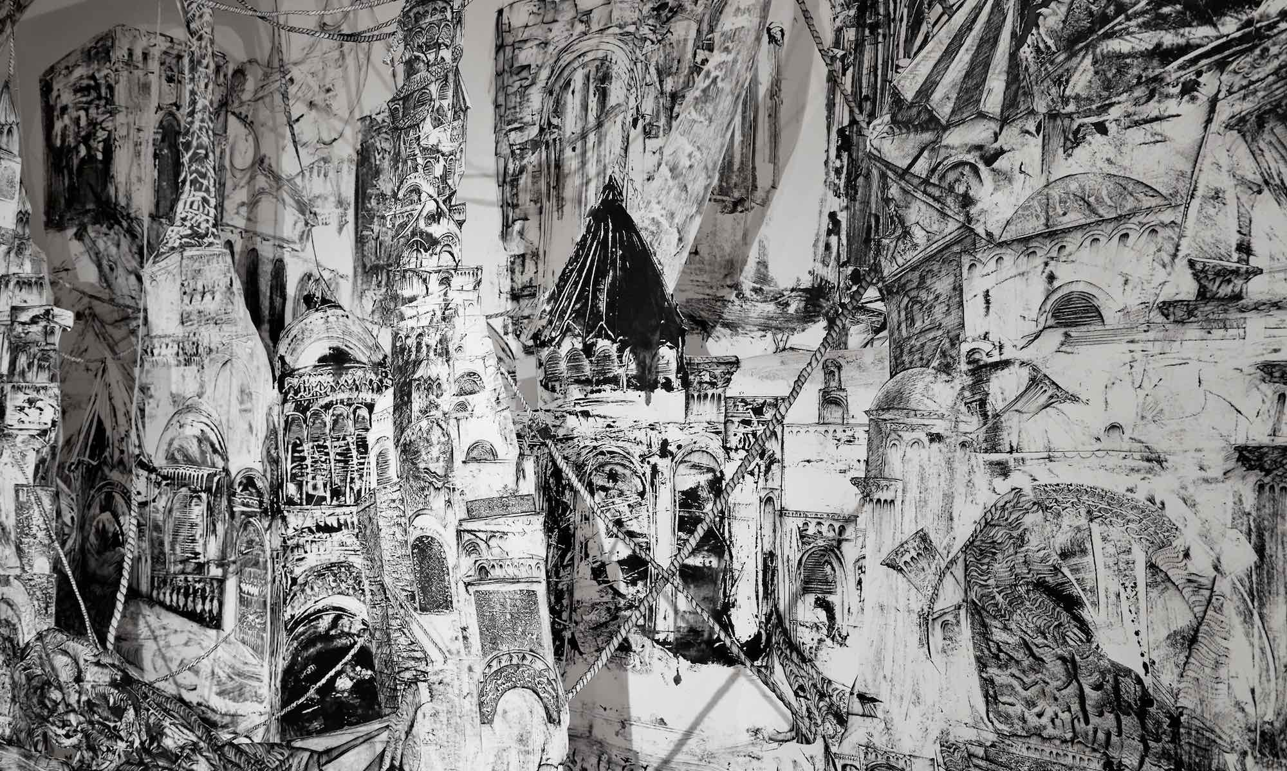
November 5, 2019
Kevork Mourad
Immortal City (2017)

Constantly striving to spark alternative conversations around the socio-political reality of the Middle East and its diaspora, Tabari Artspace is delighted to announce its first show of the new season - Between Floating Worlds - a solo exhibit of visual artist Kevork Mourad.

Pushing the boundaries of his practice Mourad forms new bonds between once disparate disciplines employing a technique of live drawing and animation in concert with musicians – developing a collaboration in which art and music harmonise with one another. His unique practice is developed through the employment of monotypes and calligraphic gestures that come together to form cut-outs and three-dimensional works. Mourad conceived this new way of creating in an attempt to create a whole world, an invented historic exploration, to trigger memory and indulge in re-discovering a universe that never existed to begin with.

The artist likens his creative process to the production of a book; like an author he takes a specific concept and builds his narrative around it. One piece leads on to another: each fresh body of work evolves from what came before. For Between Floating Worlds the artist explores the sentiments of the displaced, those who leave one world in search of a better one, but are often met with disappointment when the grass they discover is not as green as they had dreamed. His work falls into grey areas, the spaces between ‘us’ and ‘them’, old and new, a difficult past and an uncertain future, the fragile present defined by hope and anticipation, uncertainty and ambition. The pieces, produced especially for this exhibition, embody symbols of transience, travel and uncertainty - suspended creatures, ropes, and sails. Enhanced by the addition of audio, the selection of works will be complemented by the masterly arrangements of Argentinian composer Juan Pablo Jofre. The artist, drawing inspiration from myriad sources, taps the minds of musicians, philosophers and poets. The influence of Argentine short-story writer Jorge Francisco Isidoro Luis Borges Acevedo is present in his output as well as Italian novelist Italo Calvino.

As part of his practice Mourad regularly engages with aspiring artists and students; as such Between Floating Worlds will be produced in collaboration with students from local art schools, adding a regional element to the production, stimulating the local art community and evolving the practice of the new generation.

On the cross-over between art and music Kevork Mourad says:
“Music has always been a big part of my artistic practice. Sometimes I have created pieces based on music, and sometimes music has been created for my pieces. The dialogue between the two art forms has always been fascinating to me. It is magical to me when sometimes the music will seem to control the lines and gesture of the visual piece and vice versa, like a dance between the two.
When like-minded thinkers meet, it is always interesting to push the boundaries and create a project where it is about the work, not about the disparate media. A successful multi-media project is about beautiful storytelling; the collaboration should be about transmitting the idea as effectively as possible to the audience. People are seeking this kind of sophisticated collaboration. I’m always fascinated and open to collaborating with different art forms, which I have—with dancers, writers, composers, and poets.”

On Kevork Mourad’s practice Henry Kim, Director and CEO Aga Khan Museum says:
"Kevork’s work is, I think, truly extraordinary. What I have found most pleasing about the interaction between Kevork and the Museum, is that we have seen real progression in his artistic practice over the course of the three years we have known each other.
As a Museum, we are not simply keen to display the works of contemporary artists, instead we want to work collaboratively with them on the intellectual ideas of a work or display. Our chosen angles as a Museum are to explore the connections between cultures or the links between artistic practices of the past and the present. The more that we can integrate the various art forms together, whether music, visual arts, dance, poetry, the written word, the better. Because as we all know, the arts are not monolithic, they are truly diverse, and the more that we can find the links between the arts, the more creative I think the process will be.
With Kevork, we found an artist who has been intellectually curious, to explore themes of migration and displacement, or the links between the past and the present. His expression of these ideas were accompanied by changes in his creative process, as his graphic art began to move away from the two-dimensional into what you see today which is better described as a graphic sculpture, rather than simply a print or a drawing."

-ENDS-

For interviews and image requests please contact:
Laura Beaney
e. Laura@TabariArtspace.com

ABOUT KEVORK MOURAD
Kevork Mourad was born in Qamishli, a town in northeastern Syria. Of Armenian heritage, he received his Master of Fine Arts from the Yerevan Institute of Fine Arts in Armenia, and now lives and works in New York. With his technique of spontaneous painting, where he shares the stage with musicians—a collaboration in which art and music develop in counterpoint to each other—he has worked with many world-renowned musicians, including Kinan Azmeh, Brooklyn Rider, Ken Ueno, Liubo Borissov, and Issam Rafea. Mourad is a member, as a visual artist, of Yo-Yo Ma’s Silk Road Ensemble. He has performed, among others, at the Brooklyn Museum of Art, The Bronx Museum of Art, Rhode Island School of Design, Harvard University, the Morgenland Festival, Lincoln Center Atrium, the Art Institute of Chicago, the American Museum of Natural History, the Metropolitan Museum of Art, Central Park’s Summerstage, the Nara Museum in Japan, the ElbPhilharmonie in Hamburg, and Le Festival du Monde Arabe in Montreal, as well as the Aga Khan Museum in Toronto. His digital piece The Map of Future Movements toured as part of a group exhibition in Jerusalem and Ramallah, and was featured in the 2010 Liverpool Biennial. As a teaching artist with Silkroad, he has worked with public school students throughout the five boroughs of New York.

ABOUT TABARI ARTSPACE
Tabari Artspace, formerly Artspace Dubai, was established in 2003 by art collector Maliha Tabari, with the aim of promoting Middle Eastern art to a global audience.

Strategically located in Dubai, seventeen years ago the gallery embarked upon an ambitious programme of exhibitions with the aim of cultivating an international community and creating fresh discourses centered around contemporary Middle Eastern art. As a pioneer of this movement Tabari Artspace played a pivotal role in establishing the careers of the Middle Eastern Masters that are collected and exhibited internationally today.

Tabari Artspace continues to honour the masters it built in the past while introducing a new generation of artists that have matured in an era of technology, globalisation, and unprecedented socio-political issues. In 2017 the gallery rebranded from Artspace Dubai to Tabari Artspace. The name ‘Tabari’ stems from Lake Tiberias and brings into focus our understanding of borders, space, and identity - just some of the universal topics tackled by the Middle Eastern artists of the ‘now’. As Middle Eastern art continues to flourish in front of an international audience Tabari Artspace puts forward a programme of artists that challenge its conventions, push boundaries, and break down borders with fresh approaches.

“As our geographical borders blur in our era of mass-migration art has the ability to capture and communicate key social issues that are relevant for all. We now welcome a new wave of Middle Eastern artists that uphold an international outlook. A generation that seeks change and progress.”

-Maliha Tabari, 2019

VISIT TABARI ARTSPACE
Tabari Artspace,
The Gate Village Building, DIFC Dubai
t. + 971 4 323 0820
w. www.tabariartspace.com

